GYM KIDZ – FLOOR (1)
Statics | - © Tuck | 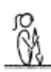 | - all positions must be performed with control and awareness  - maintain good body tension and alignment  - head neutral
 | - © Pike | 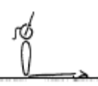 | - all positions must be performed with control and awareness  - maintain good body tension and alignment  - head neutral
 | - Closed Pike | 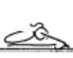 | - all positions must be performed with control and awareness  - maintain good body tension and alignment  - head neutral
 | - Front support | 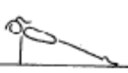 | - all positions must be performed with control and awareness  - maintain good body tension and alignment  - head neutral
 | - Rear support | 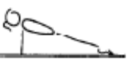 | - all positions must be performed with control and awareness  - maintain good body tension and alignment  - head neutral
 | - Tuck Dish |  | - all positions must be performed with control and awareness  - maintain good body tension and alignment  - head neutral
 | - Arch | 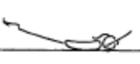 | - all positions must be performed with control and awareness  - maintain good body tension and alignment  - head neutral
 | - Shoulder stand /Candlestick | 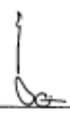 | - all positions must be performed with control and awareness  - maintain good body tension and alignment  - head neutral
Locomotion | Crawling along bench
 | Running on a masking tape line/rope
 | Running between masking tape lines/ropes
 | © Log Roll down slope on own
 | Egg roll by self
Fwd Roll  (for front salto) | 1. © Roll bwd & fwd to sit in tuck on own
 | 2. Roll bwd & fwd to sit in pike on own
 | 3. Roll bwd & fwd to sit in straddle on own
 | 4. © Fwd roll down sloped mat on own | 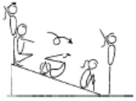 | - good speed in the rotation  - good rhythm in the rotation  - hands on the front of the shins, below the  - kneecaps  - head tucked in, with chin on chest  - stretch before and after the roll
 | 5. Fwd roll on floor with assistance | 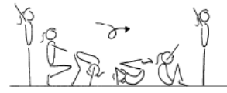 | - stretch before roll  - hands placed on the floor near the feet  - feet together  - tuck head under (look at belly button)  - roll quickly over the head  - roll should be in a neat, tight tuck, knees together and toes pointed  - roll up to stand  - stretch after roll

GYM KIDZ – FLOOR (2)
Handstand (for walkover, handspring and flic flac) | 1. Rocking over a cylinder – on stomach to place hands on floor – walk 3 steps
 | 2. Angry Cat/Happy Cat position – hold 5 secs
 | 3. © F1-2.1 Front support on Floor – hold 5 secs |  | - all positions must be performed with control and awareness  - maintain good body tension and alignment  - head neutral
Cartwheel / Roundoff | 1. F1-4.1 With hands on a raised surface, have the gymnast climb from one side to the other
 | 2. © F1-4.2 with hands on a raised surface, jump from one side to the other | 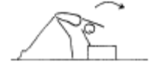 | - hands parallel, straight arms  - head neutral  - feet close to hands  - small straddle during the jump
 | 3. GF4.4 Bunny hop turn out with assistance
 | 4. Angry cat position – rocking from hand to hand
 | 5. Show star position standing with arms stretched up – feet apart – completely straight body
 | 6. Rocking stars standing on a line – no movement fwd
Leaps/Jumps | 1. © Straight jump drill from arm swing behind to stretched releve position | 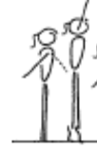 | - ensure efficient use of arms  - ensure shoulders upright at all times  - knee bend should not exceed 45’  - heels pushed forward into a high arch position  - hips under and stomach pulled in  - head up and eyes down
Turns | 1. © Learn side passé and fwd passé position – holding onto something stable
FWO, BWO & Tic Toc | 1. Bridge rocking on back lying over a cylinder – with assistance (with feet supported) | 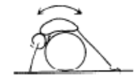 | - this drill allows the gymnast to experience the  - correct movement pattern, the gymnast can rock  - back and forth placing weight on their hands and  - then feet
 | 2. Seal hold

GYM KIDZ – BARS (1)
Hanging & Grip Strength | 1. © Possum Hang Pull Ups (laterally hang under the single bar and chin up to left ear and then right ear)
 | 2. Shimmy across
 | 3. Assisted hanging ½ turns
Tuck Swings /Glides | 1. © Swing – drop bean bag in hoop
Front Support /Casts | 1. © Front support on floor with hands on floor bar | 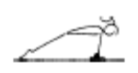 | - straight arms throughout the jump to front support  - chest rounded
 | 2. Front support on floor bar with feet raised
 | 3. Assisted Front support on bar
Fwd Roll Dismount | 1. © Tuck Hang
 | 2. Front support on bars
Pullover | 1. Holding toes to the bar spotted – 2 secs
 | 2. Chin up hold spotted– 2 secs
 | 3. © Swing on rings in tuck position 2 x fwd and bwd (with box under so gymnast remains in tuck position)

GYM KIDZ – BEAM (1)
Front support Mount | 1. © Jump to front support on own | 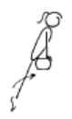 | - straight arms in front support  - legs straight during the first phase
 | 2. M1-1.3 Stride sit/support on the beam
Kneeling Scale | 1. Crawling on low beam | 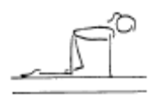 | - arms straight  - good rhythm  - head up, eyes down
 | 2. Bear walks along low beam | 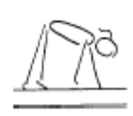 | - arms straight  - good rhythm  - head up, eyes down
Releve/Turns | 1. © On low beam – walk flat, 2, 3 – then rise to hold releve on toes – repeat along bench | 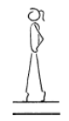 | - one foot slightly in front of the other, both legs slightly turned out  - legs squeezed together  - legs straight, knees locked  - heels pushed forward into a high arch shape  - ankles should be stable  - equal weight on both feet  - maintain good body tension and alignment
Locomotion | 1. © Walk fwd on low beam and mid beam with a crash mat under
 | 2. Walk bwd on bench – hands on hips
 | 3. GF2.9 Side steps along a bench
Jumps /Leaps | 1. © Standing on bench – flat feet, swing arms bwd with bent knees then fwd to ears as legs straighten – stay on flat feet
 | 2. M1-7.1 Perform a releve on the bench with a bean bag on head – on own |  | - one foot slightly in front of the other, both legs slightly turned out  - legs squeezed together  - legs straight, knees locked  - heels pushed forward into a high arch shape  - ankles should be stable  - equal weight on both feet  - maintain good body tension and alignment
Stride Leap | 1. Step kicks fwd on low beam or middle beam with crash mat under | 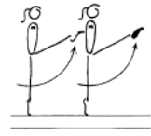 | - good rhythm  - good posture  - free leg lifted to hip height minimum  - arms are horizontal  - kicks performed on toes if possible  - support leg locked out
Landing Drills | 1. Can you move me/ shake me in landing position | 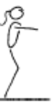 | - on landing the hips must be under  - on landing the shoulders, hips and ankles should all be in a vertical line
 | 2. Clap – don’t jump off beam until coach claps
Straight Jump Dismount | 1. © St jump off bench to HOLD land for 3 secs | 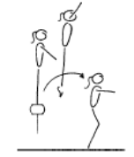 | - stretched arms overhead  - legs straight in the air  - vertical take off  - on landing the hips must be under  - on landing the shoulders, hips and ankles should all be in a vertical line

GYM KIDZ – VAULT (1)
Landing | 1. © V1-2.1 Landings off a box – straight and tuck
Bounce /Spring | 1. V1-1.1 Assisted bounces on the floor – coach holds the gymnast by the hands in front
 | 2. © V1-5 Springing circuit – 3 bean bags/teddies | 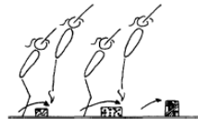 | - maintain good body tension and alignment  - continuous bouncing, no pauses or stops  - easy clearance of the objects
 | 3. GF3.7 3 x hopping steps on each leg
 | 4. Jumping bwds
 | 5. Jumping Sideways
Running | 1. Running | 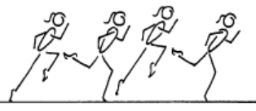 | - good body alignment  - fast action  - arms bent at 90', moving beside body  - legs moving within the body line  - body straight with slight forward lean  - maximum forward speed is essential  - head remains neutral and still
 | 2. Running bwds
Hurdles | 1. © Hurdle off a bench to a BB – arms down on BB | 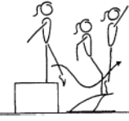 | - underarm action  - arms stop at 45’  - low approach from the box to the board  - feet lead body onto the board  - fast explosive bounce off the board  - vertical bounce off the board  - maintain tight straight body shape, with chest in, on the box
 | 2. Hurdles with 2 hoops on floor – 1 foot, 2 feet – arms down when 2 feet land

